PROJECT DEMONSTRATION
Medical Diagnosis Center by ServiceNow Service Portal
Project Name | Medical Diagnosis Center by ServiceNow Service Portal
Prepared By | Project Team
Platform | ServiceNow
Document Type | Final Project Demonstration — Workflow-Aligned

1. DEMONSTRATION PURPOSE
This demonstration follows the workflow evidenced by the supplied Medical Diagnosis Center screenshots. The focus is the implemented ServiceNow portal journey from diagnostic-test discovery and booking through patient-data capture, scheduling, payment, appointment completion, appointment tracking and laboratory-report access. The screenshots also evidence the custom Patient, Diagnostic Test, Appointment and Report tables, custom portal widgets/pages and an Appointment-table business rule for report creation.
• Demonstrate the requester-facing Medical Diagnostic Test Center portal.
• Show diagnostic-test discovery and the Book Now journey.
• Demonstrate the Details → Schedule → Payment → Done booking sequence.
• Show how booking information is represented in the Appointment table.
• Show the configured appointment-completion automation point for report creation.
• Demonstrate My Appointments and My Lab Reports.
• Explain the custom ServiceNow tables, widgets, portal pages and implementation challenges.
2. DEMONSTRATION ARCHITECTURE
The screenshot-grounded implementation path is:
Medical Diagnostic Test Center Portal → Medical Test Catalog → Book Now → Appointment Booking (Details → Schedule → Payment → Done) → Appointment Record → Appointment Completion Automation → My Appointments → My Lab Reports.
Supporting data structures shown in the screenshots: Patient, Diagnostic Test, Appointment and Report tables. Supporting portal components shown: Medical Test Catalog, Lab Reports, Appointment Booking and My Appointments widgets/pages.
PORTAL | TEST CATALOG | BOOKING | APPOINTMENT | REPORTS
Medical Diagnostic Test Center | Diagnostic Test | Details | Appointment Table | Lab Reports
Search / All Tests | Book Now | Schedule | Status / Date / Time | My Lab Reports
My Bookings | Test details | Payment | Patient reference | Report Table
3. DEMO PREREQUISITES
Requirement | Demo Readiness Check
ServiceNow Instance | PDI or authorized project instance is active and accessible.
Portal | Medical Diagnostic Test Center portal is available.
Diagnostic Tests | Test catalog contains the configured test cards and Book Now actions.
Patient Data | Use a valid demonstration patient dataset.
Appointment Data | Configured Appointment table and fields are available.
Automation | Appointment completion business rule is available for inspection.
Reports | Report table and My Lab Reports page/widget are available.
Browser | Use a clean browser session for a consistent demonstration.
4. FINAL LIVE DEMONSTRATION FLOW
Step | Demo Action | Role | What to Show | Expected Result
1 | Portal Entry | Patient / Admin | Medical Diagnostic Test Center portal | User lands on the custom ServiceNow Service Portal home page with search, My Bookings, My Reports and All Tests.
2 | Test Discovery | Patient / Admin | Medical Test Catalog widget / test_catalog page | User browses or searches available diagnostic tests and selects Book Now.
3 | Patient Details | Patient / Admin | Appointment Booking widget | User enters patient information shown in the implementation: first name, last name, email, phone, date of birth, gender and address.
4 | Schedule | Patient / Admin | Appointment Booking | User moves to the Schedule step and selects the appointment details for the chosen diagnostic test.
5 | Payment | Patient / Admin | Appointment Booking | User proceeds through the configured Payment step in the booking journey.
6 | Completion | Patient / Admin | Appointment Booking | User reaches the Done step and the booking is completed.
7 | Appointment Record | Administrator / Operations | APPOINTMENT TABLE | The booking is represented in the custom Appointment table with fields including patient, scheduled date, start/end time, status and rejection reason.
8 | Completion Automation | Administrator / Operations | Business Rule — Auto Create Report on Appointment Complete | The screenshots show a Business Rule on the Appointment table intended to automate report creation when an appointment reaches completion.
9 | My Appointments | Patient / Admin | my_appointments page / My Appointments widget | User can view appointment history and status; the screenshot shows a completed, approved appointment and a Book New Test action.
10 | Lab Reports | Patient / Admin | lab_reports page / Lab Reports widget | User can access diagnostic reports through My Lab Reports; the screenshot shows the report dashboard and its status counters.
11 | Diagnostic Data Model | Administrator / Operations | PATIENT / DIAGNOSTIC TEST / REPORT tables | The backend data model separates patient, diagnostic-test, appointment and report information.
4.1 Suggested Narration During the Live Demo
Step 1: “I will start from the Medical Diagnostic Test Center portal, where the user can search tests and access My Bookings and My Reports.”
Step 2: “From All Tests, the user selects a diagnostic test and clicks Book Now.”
Step 3: “The booking journey first collects patient information such as name, contact details, date of birth, gender and address.”
Step 4: “The user then proceeds through the Schedule step, followed by the configured Payment step, and finally reaches Done.”
Step 5: “The completed booking is represented in the custom Appointment table, which stores patient and appointment information such as scheduled date, start time, end time and status.”
Step 6: “The implementation also contains an Appointment-table business rule named Auto Create Report on Appointment Complete, providing the configured automation point for report creation after appointment completion.”
Step 7: “The user can return to My Appointments to view the appointment history and its current status.”
Step 8: “The My Lab Reports page provides the user-facing location for diagnostic reports and report status information.”
Step 9: “Behind the portal, Patient, Diagnostic Test, Appointment and Report are separated into custom ServiceNow data structures.”
5. ROLE-BASED DEMONSTRATION
Role | Key Demo Activities | Main Components
Patient / Requester | Browse diagnostic tests; select Book Now; enter patient details; schedule; complete payment flow; view appointments and reports. | Medical Diagnostic Test Center portal, Medical Test Catalog, Appointment Booking, My Appointments, My Lab Reports
ServiceNow Administrator / Developer | Configure custom tables, widgets, portal pages and business rules; validate data relationships and automation. | Patient, Diagnostic Test, Appointment, Report tables; widgets; business rules; portal pages
Diagnostic / Service Operations | Use appointment and report records for operational processing where authorized. | Appointment and Report data; role-controlled ServiceNow access
6. IMPLEMENTATION / PROBLEMS FACED AND LIVE EXPLANATION
Problem | What Happened | Resolution / Current Configuration | How to Demonstrate
Appointment-to-Report Automation | Report generation depends on the appointment reaching the configured completion state. | Business Rule 'Auto Create Report on Appointment Complete' is configured on the Appointment table. | Show the Business Rule configuration and then show the resulting report/record when available.
Patient / Appointment Data Mapping | Booking information must be represented consistently between the portal booking journey and the Appointment table. | Validated the custom Appointment fields and patient reference. | Compare the patient details entered during booking with the Appointment record.
Portal Widget / Page Flow | The user journey is split across custom widgets and portal pages. | Medical Test Catalog, Appointment Booking, My Appointments and Lab Reports widgets/pages are configured. | Navigate through the actual portal pages in sequence.
Booking Lifecycle | The booking must progress through Details, Schedule, Payment and Done. | The Appointment Booking widget implements the four-step visual journey. | Demonstrate each step and the final completed state.
7. DEMONSTRATION EVIDENCE / SCREENSHOTS
The first uploaded PDF contains 21 implementation screenshots. Pages 17–21 visibly show the implemented portal experience: the Medical Diagnostic Test Center home page, diagnostic-test cards, My Appointments, the Details/Schedule/Payment/Done booking flow and My Lab Reports. Pages 1–7 show the supporting ServiceNow tables and business rules.
Recommended evidence sequence:
• Portal home page — Medical Diagnostic Test Center.
• Medical Test Catalog — available diagnostic tests and Book Now.
• Appointment Booking — patient information / Details step.
• Appointment Booking — Schedule step.
• Appointment Booking — Payment step.
• Appointment Booking — Done/completion state.
• Appointment table — patient, scheduled date, start/end time and status.
• Business Rule — Auto Create Report on Appointment Complete.
• My Appointments — booking history and status.
• My Lab Reports — report dashboard/status view.
• Patient, Diagnostic Test and Report table definitions.
Portal Home
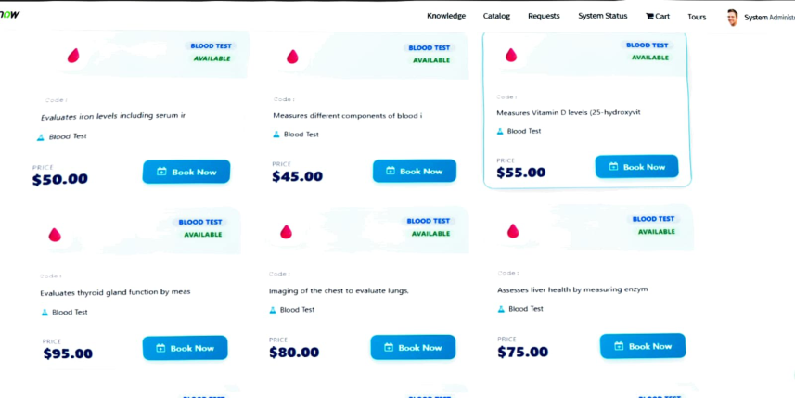
Diagnostic Test Catalog
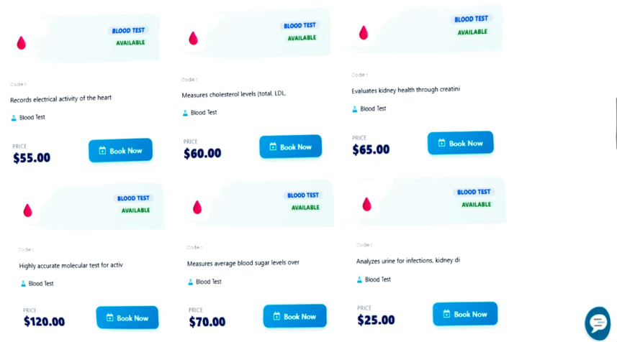
My Appointments
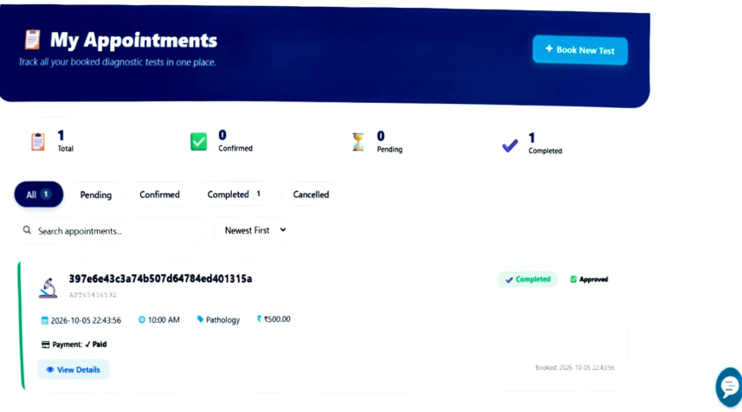
Appointment Booking / Patient Details
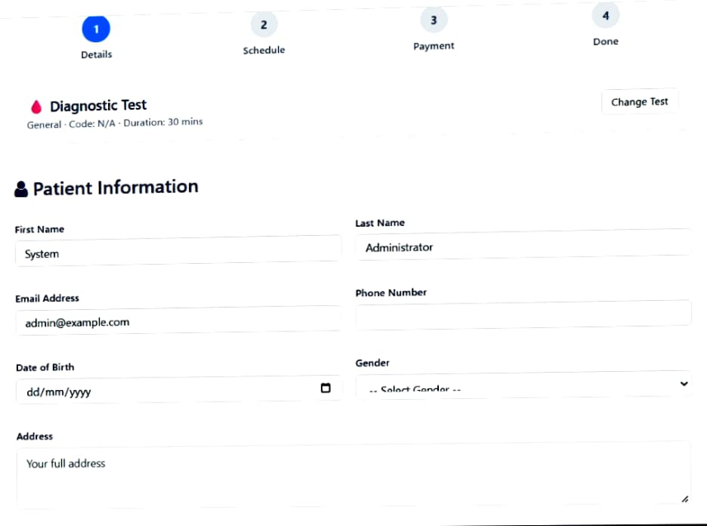
My Lab Reports
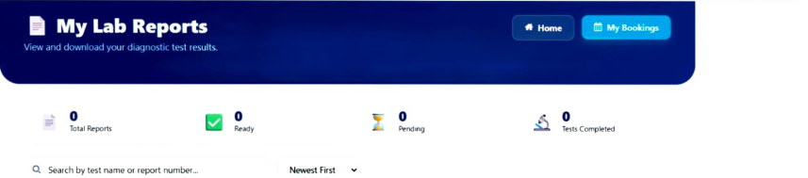
8. DEMO VALIDATION CHECKLIST
No. | Validation Item | Status
1 | Medical Diagnostic Test Center portal opens successfully. | ☐ Pass ☐ Fail
2 | Medical Test Catalog displays diagnostic tests and Book Now actions. | ☐ Pass ☐ Fail
3 | Appointment Booking opens for the selected test. | ☐ Pass ☐ Fail
4 | Patient information fields accept valid values. | ☐ Pass ☐ Fail
5 | Schedule step is reachable from the booking journey. | ☐ Pass ☐ Fail
6 | Payment step is reachable and the booking can progress to Done. | ☐ Pass ☐ Fail
7 | Appointment record contains the selected patient and configured appointment details. | ☐ Pass ☐ Fail
8 | Appointment status reflects the configured lifecycle state. | ☐ Pass ☐ Fail
9 | Auto Create Report on Appointment Complete business rule is active/configured. | ☐ Pass ☐ Fail
10 | My Appointments displays the user's booking history and status. | ☐ Pass ☐ Fail
11 | My Lab Reports page/widget is accessible. | ☐ Pass ☐ Fail
12 | Patient, Diagnostic Test, Appointment and Report tables are available in the application. | ☐ Pass ☐ Fail
13 | Configured portal pages/widgets are accessible to the intended users. | ☐ Pass ☐ Fail
14 | Authorized users can access the required operational records. | ☐ Pass ☐ Fail
9. EVALUATOR QUESTIONS — QUICK ANSWERS
Question | Answer
What is the actual user journey? | Medical Diagnostic Test Center → test selection → Book Now → patient details → Schedule → Payment → Done → My Appointments → My Lab Reports.
Which custom tables are shown? | Patient, Diagnostic Test, Appointment and Report tables are shown in the supplied screenshots.
Which portal components are shown? | Medical Test Catalog, Lab Reports, Appointment Booking and My Appointments widgets/pages are shown.
How is the appointment represented? | The Appointment table contains patient and scheduling information including scheduled date, start time, end time and status.
How is report creation automated? | The screenshots show an Appointment-table business rule named Auto Create Report on Appointment Complete, which is the configured automation point for report creation after completion.
Is the project an autonomous medical diagnosis system? | No. The demonstrated implementation is a diagnostic-service booking and workflow portal. It does not claim autonomous clinical diagnosis or treatment decisions.
Are external hospital/EMR/laboratory integrations shown? | No external integrations are evidenced by the supplied screenshots; they should not be presented as completed functionality.
Is AI/ML clinical decision support shown? | No. The supplied screenshots evidence ServiceNow portal, data tables, widgets/pages and workflow automation, not a trained clinical AI/ML model.
10. FINAL DEMONSTRATION CONCLUSION
The live demonstration should prove the implemented Medical Diagnosis Center portal as an end-to-end diagnostic-service booking and tracking workflow: a user discovers a test, starts a booking, enters patient information, progresses through scheduling and payment, completes the booking, and can then review the appointment and access the laboratory-report area. The ServiceNow backend evidence supports this journey through the Patient, Diagnostic Test, Appointment and Report tables and the configured appointment-completion automation.
The demonstration should use the actual screenshots and live instance evidence rather than claiming unsupported REQ/RITM or Flow Designer actions that are not visible in the supplied implementation screenshots.
11. DEMO SIGN-OFF
Demonstrated By ______________________________
Demo Date ______________________________
Evaluator / Reviewer ______________________________
Overall Demo Status ☐ Successful ☐ Needs Rework
Signature ______________________________

